From:
R. Berka, 1986. The transport of live fish: A review. EIFAC Technical Paper 48. 52 pages. FAO. Rome. Italy
3. CLOSED SYSTEMS OF FISH TRANSPORT
The closed systems are represented by polyethylene bags and other sealed transport units. They are used mainly for the transport of the early fry, but also brood fish. The transport of fry in polyethylene bags with oxygen is particularly widespread in the world, being used as a very effective method. It substantially reduces the total volume and weight of transport water, enables public transport to be used for fish-transport purposes, makes it possible to prolong the transport time, and is economically advantageous.

3.1 Polyethylene Bags
The bags used for fish transport in water with oxygen atmosphere are produced in a number of modifications. They are manufactured from a thin (soft) or thicker (hard) transparent polyethylene foil and usually have the shape of sack or sleeve.
The bags of the traditional shape (sacs) usually have the dimensions of 0.8–1.1 × 0.35–0.45 m. The upper end is usually fully open. The bottom either has a seam in the middle or consists of a rectangular piece of foil; the latter variant is better because it helps avoid losses of the fish squeezed in the corners. For safety reasons, the bags are sometimes duplicated: a thin (soft) bag is inserted in another thin bag, or a thin bag forms a lining in a thicker (harder) bag.
The other type of bags has the form of a sleeve. Its width usually is 0.4–0.5 m. The final length of the sleeve depends on where the sleeve is cut. One of the ends has to be completely closed, sealed: a suture is welded, or the folded end of the sleeve is fused in, after tightening with a rubber seal or a plastic adhesive tape, or binding with a rope. The welding is done with a special device, whereas for the fusing (sealing) the flame of a candle will suffice (Fig. 5). Another possibility is to bind a knot on the end of the sleeve. It is important to make the knot as tight as possible. One sleeve equalling about 2.5 times the length of the future bag suffices, after binding a simple knot, to make a duplicated bag.
During transport the bags with fry are placed in outer cases protecting the bags against mechanical damage, mainly punching or tearing in contact with the ground. The case keeps the bags in the desired position, enables easier handling and/or provides thermal insulation of the bags.
These cases can be cardboard boxes, suitable plastic containers, wide polyethylene cans, polystyrene boxes. The kind of outer casing depends on the number of bags transported, length and method of transport, requirements for further handling (transloading), and on the differences between ambient temperature and the temperature of water inside the bag.
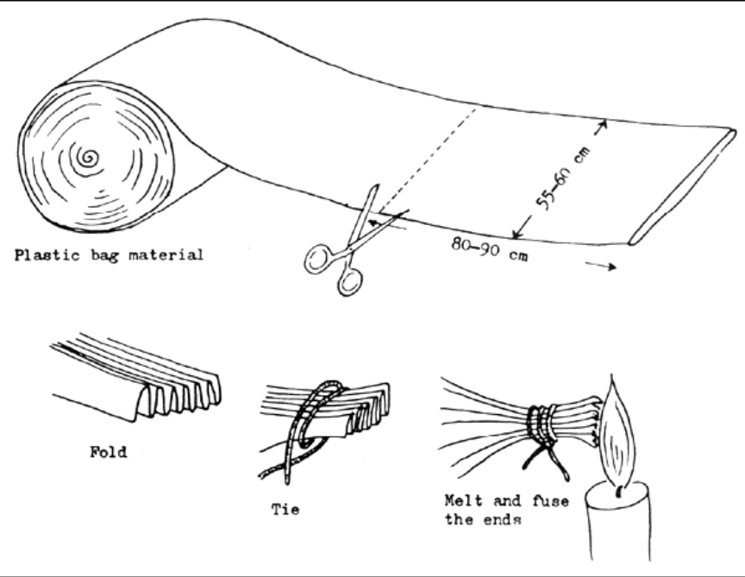Figure 5 Procedure of closing the bottom end of a polyethylene sleeve (Woynarowich and Horváth, 1980)
If water with transported fry is to be cooled, bags with ice should be placed under the fish-transport bags on the bottom of the polystyrene box (Fig. 6). It is not recommended to put the ice inside the transport bag. The amount of ice depends on the size of the bag with water, transport time and difference of temperature. The volume of ice placed under the bag with transport water is usually 10–20% of the transport water. This method of packing enables transport by public transport routes.
The water to be used for fry transport in a bag should comply with all requirements. It is best to use water of the same quality as that in which the fish were kept before transport, but there should be no organic pollutants and no dispersed mud of mineral origin. Sac fry, in particular, need transport water with air bubbles, i.e., released air contained in water in oversaturated condition.
Before putting the fry in the bag, the procedure of catching, counting and distributing the fry in the bags should have been thoroughly prepared to finish the operation as quickly as possible.
The polyethylene sac, or sleeve with a closed bottom end, is first put in the outer transport case; if a double bag is to be used the inner bag is to have been inserted in the outer one. Then, water is poured in the bag, about 20 litres if the volume of the bag is 50 litres, and the fry are placed inside. Air is displaced from the space above water in the bag and a hose, connected to the pressure regulator of an oxygen cylinder, is introduced in the bag, the upper end of the bag being held tight around the hose by hand. Then, technical oxygen from the pressure cylinder is left to blow via the pressure regulator to the upper part of the bag. If the volume of water with fry is 20 litres, the volume of oxygen atmosphere should be 30 litres. The supply of oxygen is stopped when the bag is filled: the hose is quickly drawn out of the bag and the upper end of the bag is twisted to prevent oxygen from leaking and to produce some overpressure by reducing the volume. If the bag if to be transported in a horizontal position, the pressure should be 0.05 to 0.06 MPa but for vertical transport the pressure should be 0.02 to 0.04 MPs (Pecha, Berka and Kouril, 1983; Orlov et al., 1973). In practice, this means that after filling the bag is tight: when pressed with thumb the foil quickly returns to its original position. During air transport the pressure in a vertically kept bag reaches -0.01 MPa (Orlov et al., 1973), owing to the lower outside pressure. Finally the opening of the bag is closed. There are several ways of closing the bag; the simplest way is to tighten the end of the plastic foil with rubber, preferably duplicated. Rope or adhesive tape can also be used. The bag can also be closed with a metal screw cap. The procedure of bag filling is described in Fig. 7.
In hatcheries or fry rearing farms with regularly repeating mass dispatching of the fish, it is recommended to build a dispatching line (Fig. 8).
After transport, or during control on a longer journey, the condition of the fry should be checked before release. The fry are examined for position, i.e., swimming, lying on the bottom, staying in physiological position or turning to one side, for motility, readiness of reaction to light, touch, and/or number (proportion) of dead individuals.
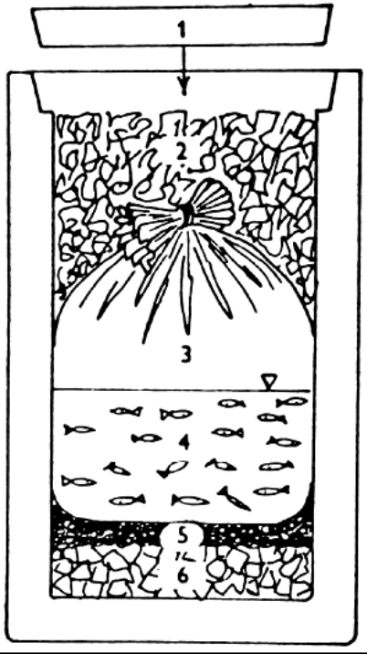

Figure 6 Transport of a bag in styrofoam case (Vollmann-Schipper, 1975) 1 - lid, 2 - insulation filling, 3 - oxygen atmosphere, 4 - water with fish, 5 - insulation lining, e.g., foam rubber, 6 - ice
The fish are released only when the temperature of the water in the bag reaches the same level as that of the receiving water. For sac fry the difference in water temperature should not be greater than 1°C, for older fry 2°C in both directions. To balance the temperatures it is best to put the closed bag on the surface of the receiving water. When the temperature difference is reduced to 2–3°C at the maximum, the bags are opened step by step and the receiving water is slowly added to the transport water. Releasing can start when about 50% of the receiving water has been added to the bags. The behaviour of the fry should be constantly examined.

. . .

5.1 Use of Fish Tranquilizers
During transport, sedation of the fish is desirable, since oxygen consumption and CO₂ and NH₃ production are all decreased. However, deep sedation is undesirable because the fish may fall to the bottom, pile up and smother. If pumps are used, the fish may be pulled into the screen, the air may move the deeply sedated fish about and cause a loss of scales. It is best to sedate the fish in the holding facility for 30 min before loading and then to continue exposure to a lower concentration of sedative during transport. The use of anaesthetics should not be relied on for increased load carrying capacity. Other methods are safer and dependable. The use of anaesthetics on food fish that will be consumed soon after exposure is not legal. Consideration should always be given to the legal status of a chemical and possible consequences to the consumer.
Anaesthesia usually applies only to transported brood fish. In practice, the fish are first tranquilized with the normal dose and put into the transport tank, where original concentration is diluted by 50 percent by adding the same amount of fresh water. The brood fish will remain tranquillized well in that diluted solution (Woynarowich and Horváth, 1980). It is advisable to find out the right dose for the fish in question through experimentation. Sensitivity resistance and endurance vary from fish to fish. Even the near related species may differ very much in this respect.

